
MATHEMATICS DEPARTMENT
Year 11 Specialist – 2016
Test Number 7: Resource Free
Transformation Matrices and Trigonometric Functions

Name: _______________________________________ Teacher: DDA
Marks: 41
Time Allowed: 45 minutes
Weight: 7%
Instructions: Show your working where appropriate remembering you must show working for questions worth more than 2 marks.
Part A multiple-choice questions 1 mark each: 3 marks
1 Which of the following does the matrix represent?
A A translation 2 to the right and 3 up
B A dilation by a factor of 2 in the x-direction and 3 in the y-direction
C A translation 2 up and 3 to the left
D A dilation by a factor of 3 in the x-direction and 2 in the y-direction
E A reflection in the line y = x.
[1 mark]
2 Which of the following is the matrix for a rotation of around the origin?
A
B
C
D
E

[1 mark]
3 What is the image of the triangle A(2, 4) B(4, 6) C(8, −2) after a rotation of 30° around the origin?
A
B
C
D
E

[1 mark]

Part B
7 short answer questions
25 marks
Show your working where appropriate.

4 The amplitude, period and phase shift of the graph y = 6 sin are respectively:
Amplitude = 6
Period = 2$π$
Phase Shift = $\frac{π}{4}$horizontally to the left
[3 marks]

5 The rectangle A(5, −2) B(8, 2) C(0, 8) D(−3, 4) is dilated by the 2 factor in the x-direction and 1.5 in the
y-direction.
a Find the image of the rectangle under the transformation.
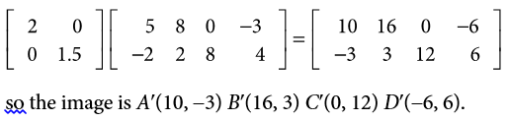

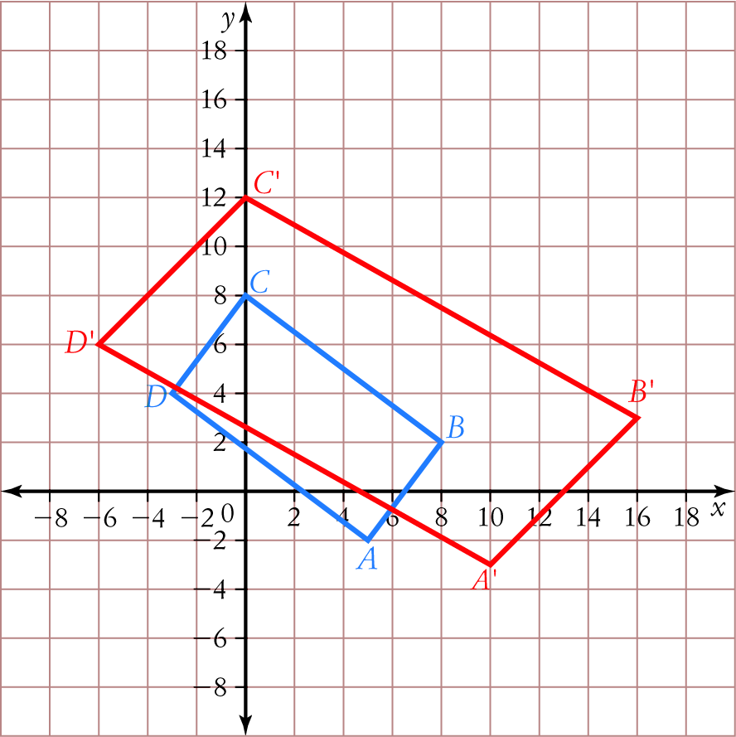
b What is the shape of the image?
Parallelogram

[4,1: 5 marks]
6 a What is the matrix for a reflection across the line y = −0.5x?
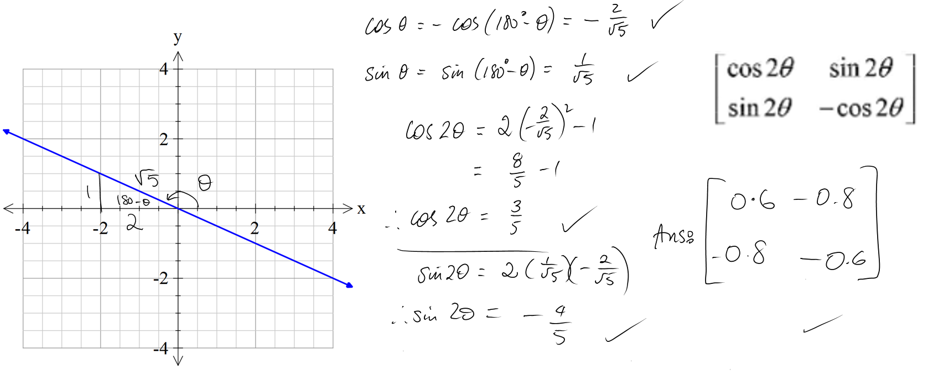 [5 marks]
7 Find the area of the image of the triangle A(−2, 4) B(8, 4) C(1, −1) after the transformation
T: (x, y) → (3x + 2y, 2x + 5y).
$$\left[\begin{matrix}3 & 2 \\ 2 & 5\end{matrix}\right]$$
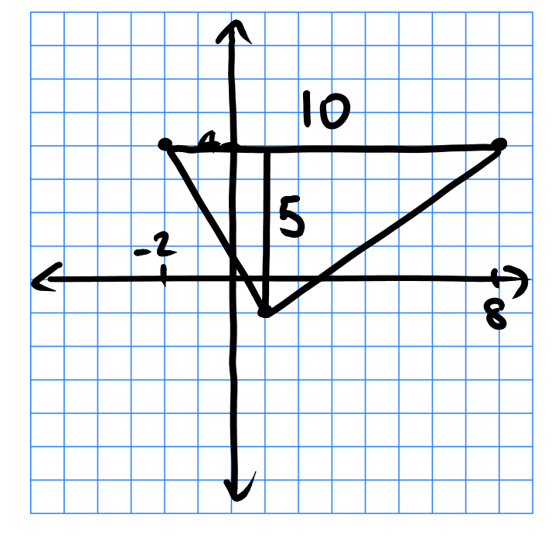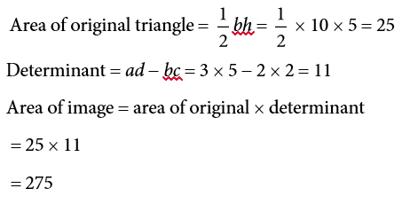

[4 marks]
8 Solve the equation 2 sin = −1 for 0 ≤ x ≤ π.
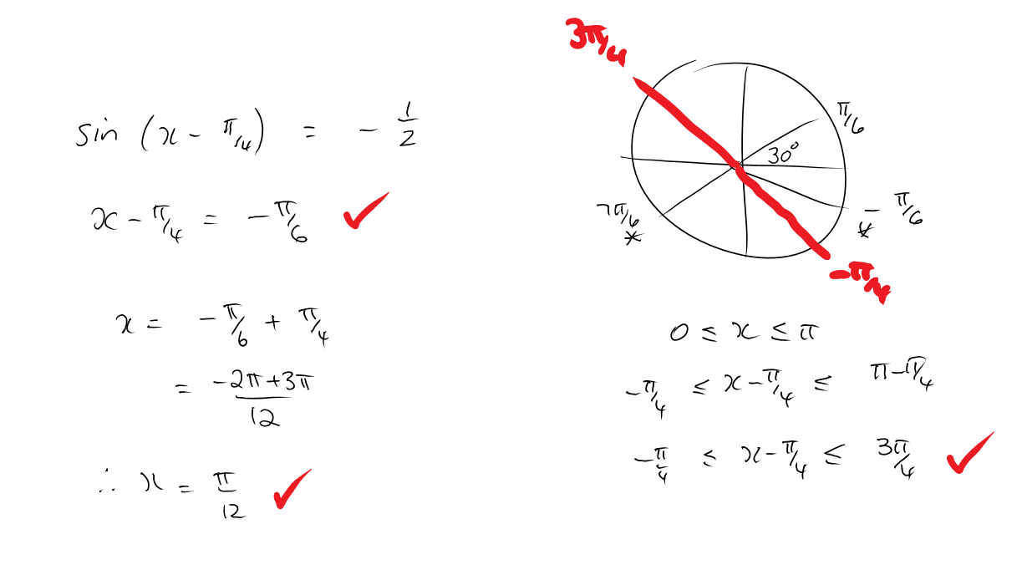

[3 mark]

9 Sketch y = 1 − 2 tan (x) for 0 ≤ x ≤ 2
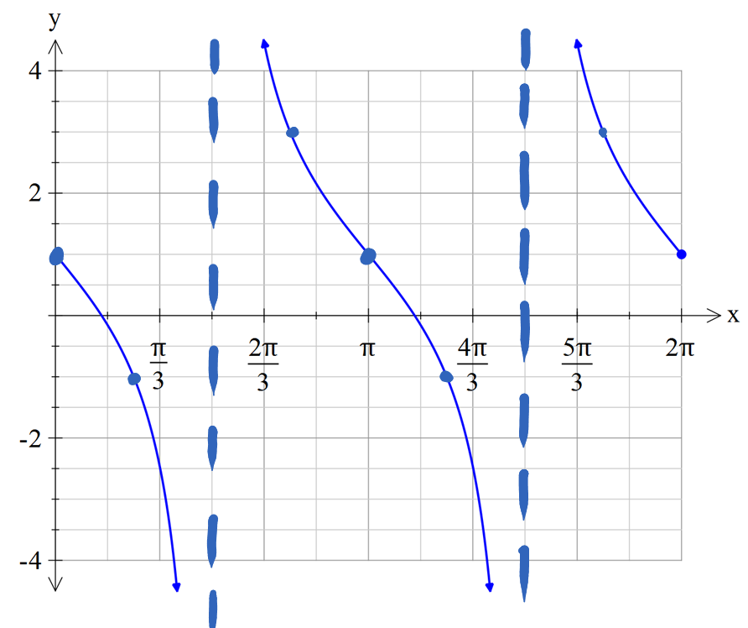
[2 marks]

10 The displacement of a particle is given by x = 2 sin (t) − 3 cos (t).
a Find the amplitude and period of the motion.
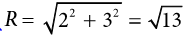

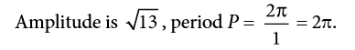

[2 marks]
b Find the greatest distance of the particle from the centre point.
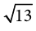

[1 mark]
Part C 3 analysis questions
13 marks
Show your working where appropriate.

11 T1 and T2 are both reflections across lines through the origin.
Use matrices to prove that is a rotation through the angle (2θ − 2φ).
Let the matrix for T1 = and the matrix for T2 =

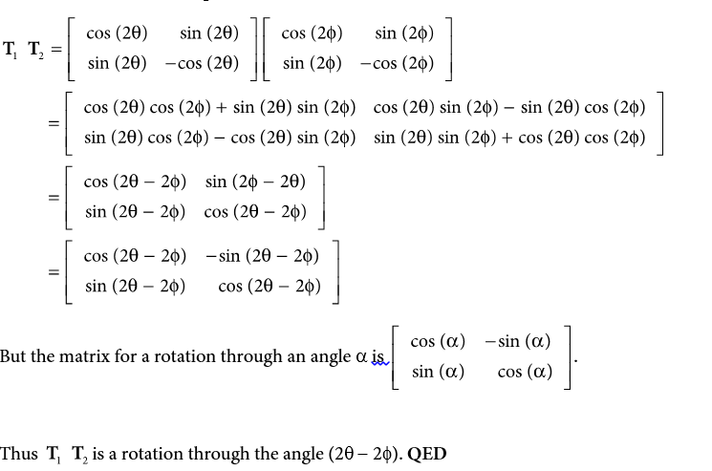

[6 marks]

12 The temperature in a greenhouse is reasonably modelled by the function
T = −4 cos, where t is the number of hours since 4.00 a.m. and T is the temperature in °C.
a Calculate the temperature at 8.00 a.m.
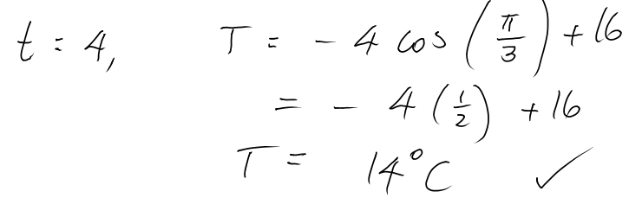

b When does the temperature first reach 20 °C?
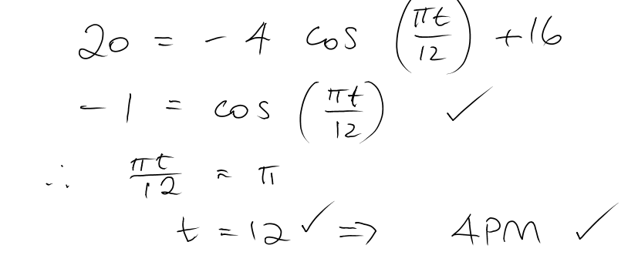

[4 marks]
13 A large hoop is rolling along the ground. The vertical distance above the ground of a point P on the rim of the hoop is given by y = 1.25 $-$ 1.25 cos (2πt) where y is in metres and t is in seconds.
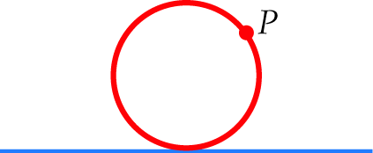
Graphically this looks like:
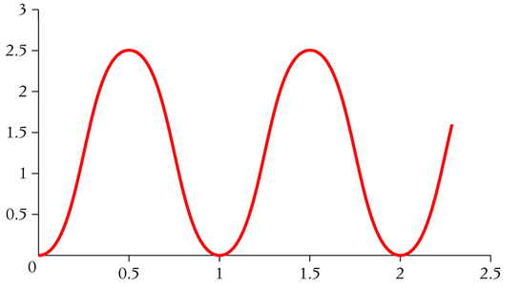

Find the first three times at which P is 2.5 m above the ground.
O.5s, 1.5s, 2.5s

[3 marks]

